JOB PORTAL MANAGEMENT SYSTEM

School of Computing

Bachelor of Technology in
Computer Science & Engineering By
S.NAVEEN(VTU26282)
10211CS224
Full Stack Application Development Slot : E1


DEPARTMENT OF COMPUTER SCIENCE AND ENGINEERING SCHOOL OF COMPUTING

VEL TECH RANGARAJAN Dr.SAGUNTHALA R&D INSTITUTE OF SCIENCE AND TECHNOLOGY
(Deemed to be University Estd u/s 3 of UGC Act, 1956)
CHENNAI 600 062, TAMILNADU, INDIA
May, 2026

BONAFIDE CERTIFICATE
It is certified that the work contained in the Full Stack Application Development report titled ”JOB PORTAL MANAGEMENT SYSTEM” by S.NAVEEN (VTU26282) has been carried out in Winter semester of Academic year 2025-2026 (WS2526).

Signature of Faculty
DR.HEMAMALINI.S
Associate Professor
Computer Science & Engineering
School of Computing Vel Tech Rangarajan Dr.Sagunthala R&D Institute of Science and Technology
May, 2026

Signature of Course Coordinator
Dr. Sumithra M. Assistant Professor (Senior Grade) Computer Science & Engineering
School of Computing Vel Tech Rangarajan Dr.Sagunthala R&D Institute of Science and Technology
May, 2026

DECLARATION
I declare that this written submission represents my ideas in my own words and where others’ ideas or words have been included, we have adequately cited and ref-erenced the original sources. I also declare that i have adhered to all principles of academic honesty and integrity and have not misrepresented or fabricated or falsified any idea/data/fact/source in our submission. I understand that any violation of the above will be cause for disciplinary action by the Institute and can also evoke pe-nal action from the sources which have thus not been properly cited or from whom proper permission has not been taken when needed.

(S.NAVEEN)
Date:06/05/2026

ABSTRACT

The proposed system is a full-stack web application designed to streamline the recruitment process by connecting job seekers and em-ployers on a single platform. Traditional hiring methods often involve manual coordination, lack of centralized data, and absence of real-time updates, leading to inefficiencies and difficulties in managing job ap-plications. This application addresses these challenges by providing a centralized, user-friendly platform that enables seamless job discov-ery, application submission, and recruitment management. The system leverages modern web technologies such as HTML, CSS, Bootstrap, and Spring Boot to build a dynamic and responsive user interface, en-suring a smooth user experience across devices. It integrates features such as job listing, user registration and authentication, job posting, application tracking, and dashboard management.
Keywords: ob Portal, Recruitment System, Web Application, React js, MySQL, User Interface, Real-time Data Processing, Job Search, Application Management, Full Stack Development.

LIST OF FIGURES

  - framework of Job portal management system . . . . . 3

  - Frontend Structure . . . . . . . . . . . . . . . . . . . 6
  - Frontend Structure . . . . . . . . . . . . . . . . . . . 8
  - Execution Diagram . . . . . . . . . . . . . . . . . . . 9
  - Proposed System Architecture 11
  - DataFlow Diagram 12
  - Job Portal Registration Page 16
  - job vacancies 17
  - Getting notification by Gmail 17

LIST OF TABLES

  - Application Comparison 17
  - Mapping of Project to Complex Engineering Problem (CEP) 23
  - Mapping of Project to Complex Engineering Activities (CEA) 24
  - SDG Mapping for the Project 25

LIST OF ACRONYMS AND ABBREVIATIONS

API | Application Programming Interface
CRUD | Create Read Update Delete
CSS | Cascading Style Sheets
DB | Database
HTTP | HyperText Transfer Protocol
HTTPS | HyperText Transfer Protocol Secure
JS | JavaScript
MVC | Model View Controller
OOP | Object Oriented Programming
SQL | Structured Query Language
UI | User Interface
UX | User Experience

TABLE OF CONTENTS

Page.No

ABSTRACT iii
LIST OF FIGURES iv
LIST OF TABLES v
LIST OF ACRONYMS AND ABBREVIATIONS vi
- INTRODUCTION 1
  - Introduction . . . . . . . . . . . . . . . . . . . . . . . 1
  - Aim of the Project . . . . . . . . . . . . . . . . . . . . 2
  - Scope of the Project . . . . . . . . . . . . . . . . . . . 2
  - Framework . . . . . . . . . . . . . . . . . . . . . . . 3
- SURVEY OF SIMILAR APPLICATION IN MARKET 4
- FRAMEWORK DESCRIPTION 5
  - Frontend Implementation . . . . . . . . . . . . . . . . 5
  - Backend Implementation . . . . . . . . . . . . . . . . 7
  - Database Implementation . . . . . . . . . . . . . . . . 9
- METHODOLOGIES 11
  - Project Architecture 11
  - DataFlow Diagram 12
  - Module 1:User Interface Module 13
  - Module 2:API and Backend Module 13
  - Module 3: :Database Module 14
- RESULTS AND DISCUSSIONS 16
- CONCLUSION AND FUTURE ENHANCEMENTS 18
  - Conclusion 18
  - Future Enhancements 18
- ADDRESSING COMPLEX ENGINEERING PROBLEM AND SDG 20
  - Mapping of the Project to Complex Engineering Prob-
lem (CEP) 20
  - Mapping of the Project to Complex Engineering Ac-tivities (CEA) 20
  - SDG Mapping 20
References 22

Chapter 1 INTRODUCTION

Introduction
The Job Portal Management System is a web-based recruitment platform that helps job seekers and employers communicate in an or-ganized way. In traditional recruitment, students or candidates need to search for jobs manually, submit resumes separately, and wait for up-dates without proper tracking. Employers also face difficulty in man-aging multiple applications, filtering suitable candidates, and main-taining recruitment records.[3] The proposed system solves these prob-lems by providing a centralized platform where students can register, login, search jobs, apply for suitable positions, and track their applica-tion status. Employers can login, post job vacancies, view applicants, and update application status. This improves the speed, accuracy, and transparency of the recruitment process.

Aim of the Project

The main aim of this project is to design and develop a full-stack Job Portal Management System that simplifies job searching and re-cruitment activities. The system focuses on providing secure login, role-based access, job posting, job searching, application management, and database storage using modern web technologies.A full-stack Job Portal Management System that simplifies job searching and recruit-ment activities. The system focuses on providing secure login, role-based access, job posting, job searching, application management, and database storage using modern web technologies[9].

Scope of the Project

The scope of this project includes the development of a digital re-cruitment system for students and employers. Students can create an account, search for jobs based on skills or location, apply for jobs, and check application status. Employers can post new jobs, edit or delete job details, view applications, and shortlist or reject candidates[8]. The system is mainly suitable for college-level placement activities, small organizations, and academic recruitment support. Future im-provements can include resume upload, email notification, AI-based job recommendation, interview scheduling, and cloud deployment.

Framework

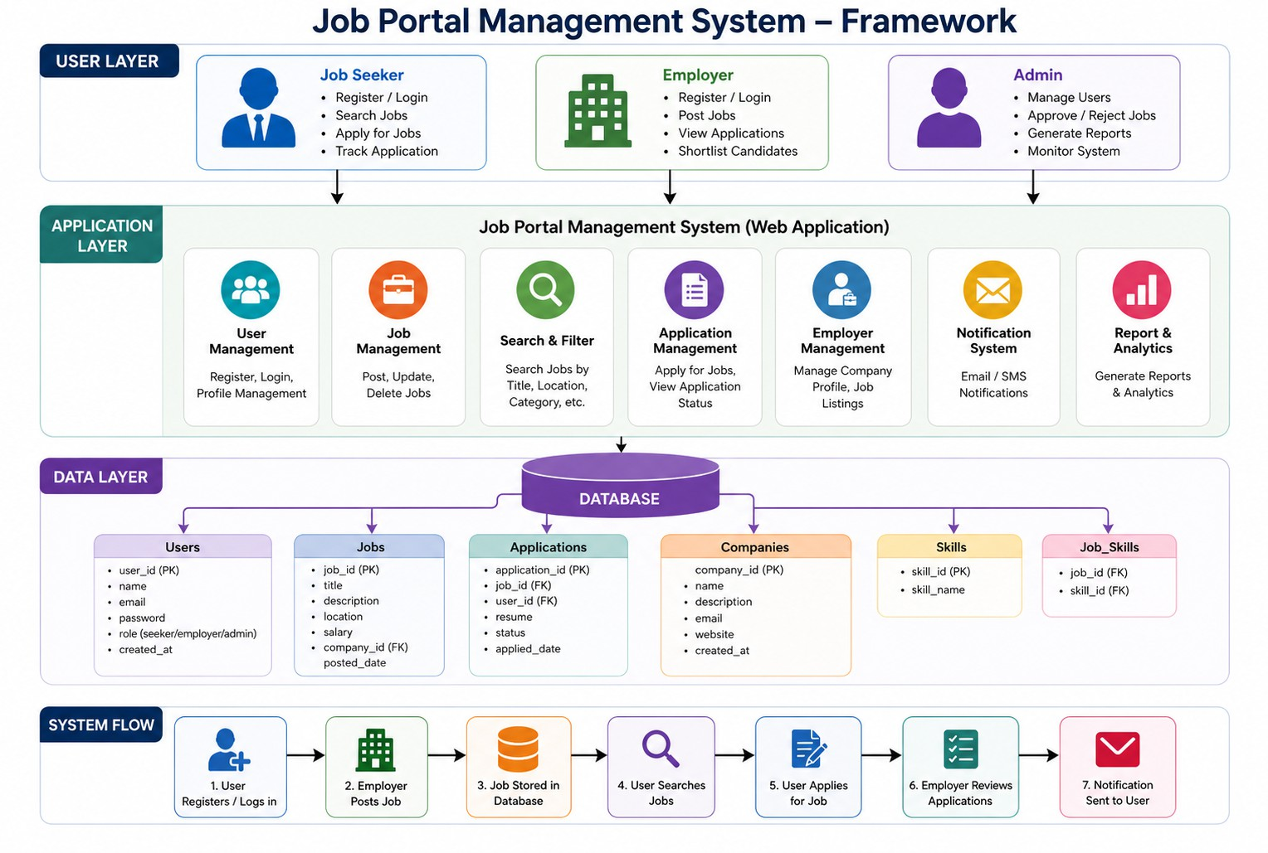
Figure 1.1 shows the proposed Job Portal Management System is developed using modern web technologies such as HTML, CSS, and Bootstrap for building dynamic and responsive user interfaces. These technologies provide a flexible and efficient environment for designing interactive web pages that allow users to easily access system features such as job search, application submission, and dashboard manage-ment.

Figure 1.1: framework of Job portal management system

Chapter 2

SURVEY OF SIMILAR APPLICATION IN MARKET

In the modern digital era, online job portals have become an es-sential part of the recruitment process, providing a centralized plat-form for job seekers and employers to interact efficiently. These sys-tems eliminate the need for traditional hiring methods such as manual resume submission and offline interviews, replacing them with digi-tal solutions that offer faster communication and improved accessibil-ity. Although these systems have significantly improved hiring pro-cesses, they are often designed for large-scale applications and may not be suitable for smaller or academic environments. Several popular job portals such as LinkedIn[1], Naukri, Indeed, and Internshala are widely used across different industries. LinkedIn is a professional net-working platform that allows users to create detailed profiles, connect with professionals, and apply for jobs[2].

Chapter 3 FRAMEWORK DESCRIPTION

Frontend Implementation

    - Environment Setup
Figure 3.1 shows the frontend development environment is set up using standard web technologies such as HTML, CSS, and Bootstrap for designing the user interface. The backend is developed using Spring Boot, and MySQL is used for database management. The project is de-veloped using Visual Studio Code as the primary IDE, with Java De-velopment Kit (JDK 17 or above) installed for backend execution[3]. Maven is used for dependency management in the Spring Boot appli-cation. Version control is handled using Git and GitHub to maintain project versions and collaboration. The application is tested using web browsers such as Google Chrome to ensure proper functionality and responsiveness.

Structure of the Project
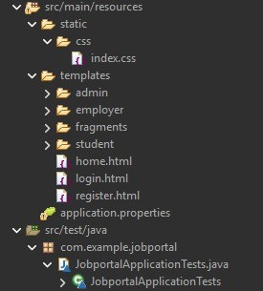
Figure 3.2 shows about to run the application, the required depen-dencies are first installed using Maven. The Spring Boot application is then executed using the run command from the IDE or terminal. The MySQL database is configured and connected using application prop-erties. Once the backend server is running, the frontend pages can be accessed through a web browser[8]. Users can register and log in to the system, search for jobs, and apply for available positions.

Figure 3.1: Frontend Structure

Execution Procedure
The backend environment is configured using Spring Boot with Java as the programming language. MySQL is used as the relational database system for storing application data. The database is managed through the MySQL command line interface or tools such as MySQL Work-
bench. The Spring Boot application is configured using application.properties file, which includes database connection details such as URL, user-
name, and password.

Backend Implementation

    - Environment Setup
The backend environment is set up using server-side technologies such as Node.js or PHP. A suitable development environment like Vi-sual Studio Code is used along with necessary extensions. For Node.js, package management is handled using npm, while PHP may require a local server like XAMPP or WAMP. A database system such as MySQL is installed and configured to store application data securely.

Structure of the Project

Figure 3.3 shows about the backend follows an API-based architec-ture using RESTful services. It includes endpoints such as /api/jobs to fetch job listings, /api/apply to submit job applications, and /api/auth for login and registration. The system uses entity classes to represent database tables such as users, jobs, and applications. The repository layer uses JPA (Java Persistence API) to perform database operations. The service layer handles business logic such as job posting, appli-cation processing, and au8 thentication. The frontend communicates with these APIs using HTTP requests and receives responses in JSON format. Execution Procedure The backend is executed by first start-ing the MySQL service and ensuring the database is properly con-figured[4]. The Spring Boot application is then started using the run

command. Once the server is active, the application begins listening for API requests. The frontend sends requests to the backend for oper-ations such as fetching job listings and submitting applications.
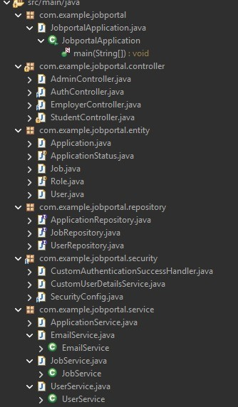

Figure 3.2: Frontend Structure

Execution Procedure
Figure 3.4 shows about the execution procedure of the Job Portal Management System involves setting up and running both the fron-tend and backend components to ensure smooth functionality of the application. Initially, the required software such as Node.js, a code ed-itor, and MySQL database must be installed and configured properly. The backend server is developed using Node.js and is started by run-ning commands such as node app.js or npm start. Once the server is running, it establishes a connection with the MySQL database, which stores all user, job, and application data[6].

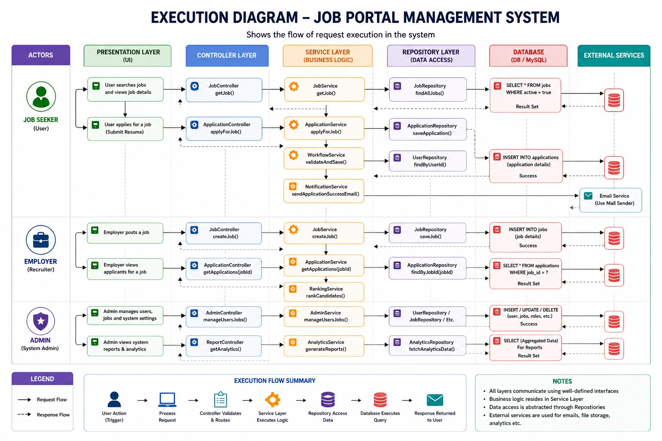

Figure 3.3: Execution Diagram

Database Implementation

    - Database Configuration
The database is configured using MySQL to store and manage user, job, and application data. A database named jobportal is created and selected using SQL commands. The configuration is performed through the MySQL command line interface[5], ensuring proper setup for data storage and retrieval operations required by the Job Portal Manage-ment System.

Schema Structure
The database schema is designed to efficiently handle recruitment

and job application information. It includes structured tables with ap-propriate fields such as user details, job details, and application de-tails. The user details include name, email, password, and role. The job details include job title, company name, location, skills, salary, and description. The application details include student name, email, job title, company, location, status, and applied date. Relationships can be maintained using identifiers such as user ID and job ID to link appli-cations with the corresponding user and job

Tables Created
The main tables created in the database include the users table, jobs table, and applications table. The users table stores information about students and employers such as name, email, password, and role. The jobs table stores job-related information such as job title, company, lo-cation, skills, salary, and job description. The applications table stores application details including student name, email, job title, company, location, application status, and applied date. These tables enable effi-cient storage, retrieval, and management of recruitment data.

Chapter 4 METHODOLOGIES

Project Architecture

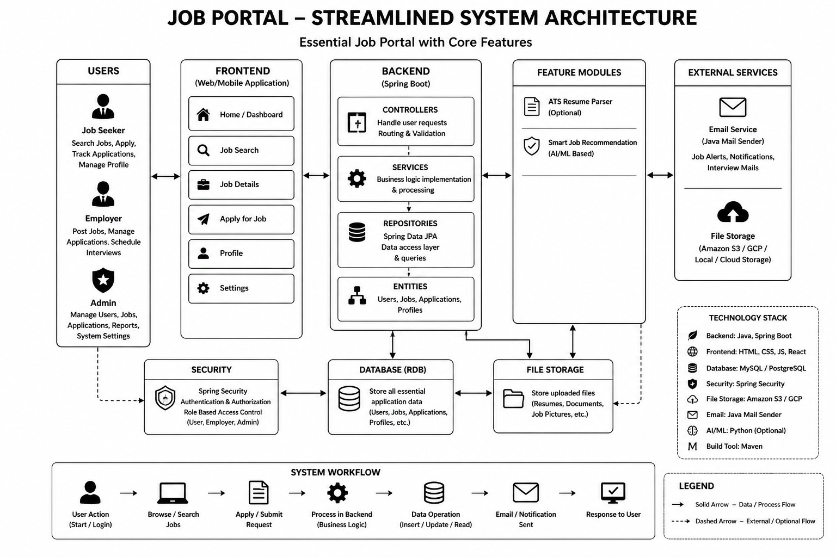

Figure 4.1: Proposed System Architecture

Figure 4.1 shows the Job Portal Management System follows a pre-sentation, application, and database layers. The presentation layer in-

cludes the frontend developed using HTML, CSS, which allows users to register, log in, search for jobs, and apply for job opportunities.

DataFlow Diagram

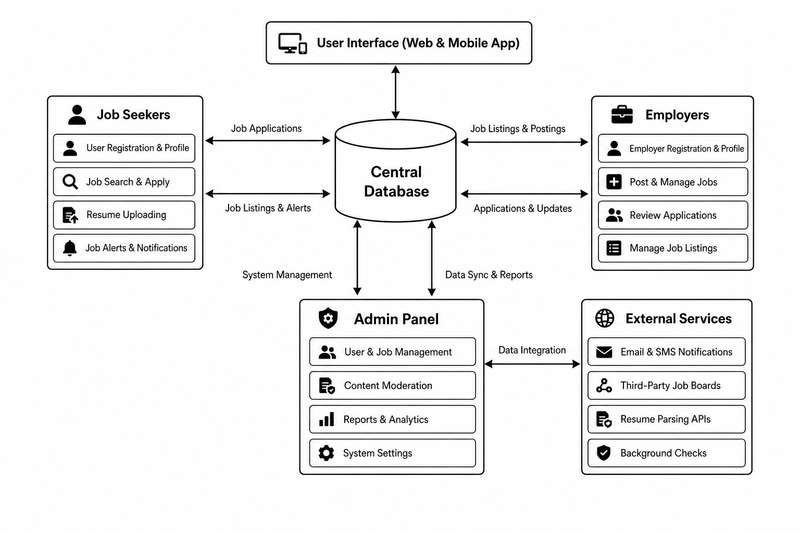

Figure 4.2: DataFlow Diagram

Figure 4.2 shows the data flow begins when the user accesses the web application and logs into the system. The frontend sends a re-quest to the backend API to authenticate the user and retrieve relevant data. Once logged in, students can search for job listings, and the fron-tend requests job data from the backend. When a student applies for a job, the application form data is validated and sent to the backend

server. The backend processes the request, stores the application de-tails in the MySQL database, and updates the application status. Simi-larly, employers can post jobs, which are stored in the database through backend processing.

Module 1:User Interface Module

The UI module is responsible for collecting user input and display-ing relevant data retrieved from the backend server. It communicates with the backend through APIs and dynamically updates the content without reloading the entire page. Features such as form validation, search functionality, and dashboard display are handled within this module. The use of modern UI frameworks ensures faster perfor-mance, attractive layouts, and better user experience. Overall, the User Interface Module plays a crucial role in making the system interactive, visually appealing, and easy to use.

Module 2:API and Backend Module

The backend module processes client requests, validates user input, and interacts with the MySQL database to store and retrieve data. It also implements security mechanisms such as authentication and au-thorization to protect sensitive user information. Middleware compo-

nents are used for error handling, request validation, and managing API responses. The use of REST APIs ensures that the system is mod-ular, flexible, and can be easily integrated with different frontend tech-nologies. Overall, the API and Backend Module acts as the backbone of the system by ensuring data integrity, security, and efficient com-munication.

Module 3: :Database Module

The database module ensures data consistency, integrity, and se-curity through proper schema design and constraints such as primary keys and foreign keys. It supports operations like inserting new records, updating existing data, deleting unwanted entries, and retrieving in-formation based on user requests. The backend communicates with the database using structured queries (SQL) to perform these opera-tions efficiently. Overall, the Database Module plays a vital role in maintaining the reliability and performance of the system by ensuring accurate and secure data management.

Advantages of this Project
The Job Portal Management System provides a simple and efficient way to manage recruitment activities in a digital format. It allows job seekers to easily search for jobs and apply online without any man-

ual effort. Employers can post job vacancies and manage applications from a single platform, which reduces time and improves productiv-ity. The system also helps in maintaining all records in an organized manner, making it easy to retrieve and update data whenever required. Additionally, the platform is accessible at any time and from any loca-tion, providing convenience to users. The use of modern technologies ensures a smooth, responsive, and user-friendly experience for both job seekers and employers.

Disadvantages
Despite its benefits, the Job Portal Management System has certain limitations. The system depends completely on internet connectivity, which can be a problem in areas with poor network access. There are also security concerns, as user data such as personal details and login credentials must be protected from unauthorized access. The system may face technical issues like server downtime or bugs, which can affect user experience. In some cases, fake job postings or incorrect information may reduce the reliability of the platform. Moreover, reg-ular maintenance and updates are required to keep the system running smoothly, which may increase the overall cost. However, these issues can be minimized with proper security measures and system improve-ments.

Chapter 5

RESULTS AND DISCUSSIONS

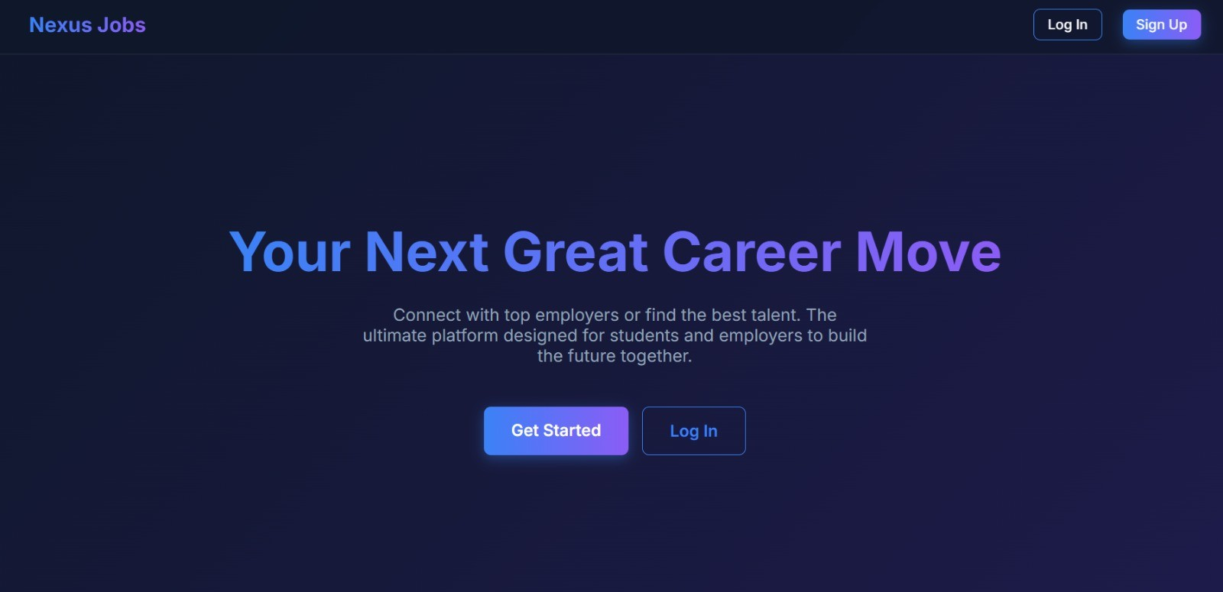
Figure 5.1 shows the application allows users to register, log in, search for job opportunities, and apply for jobs efficiently

Figure 5.1: Job Portal Registration Page

This Fig 5.2 is the main dashboard of the Job Portal system. It displays job listings, provides a search feature, and allows users to view job details and apply. It also includes navigation options such as dashboard, job posting, and logout.

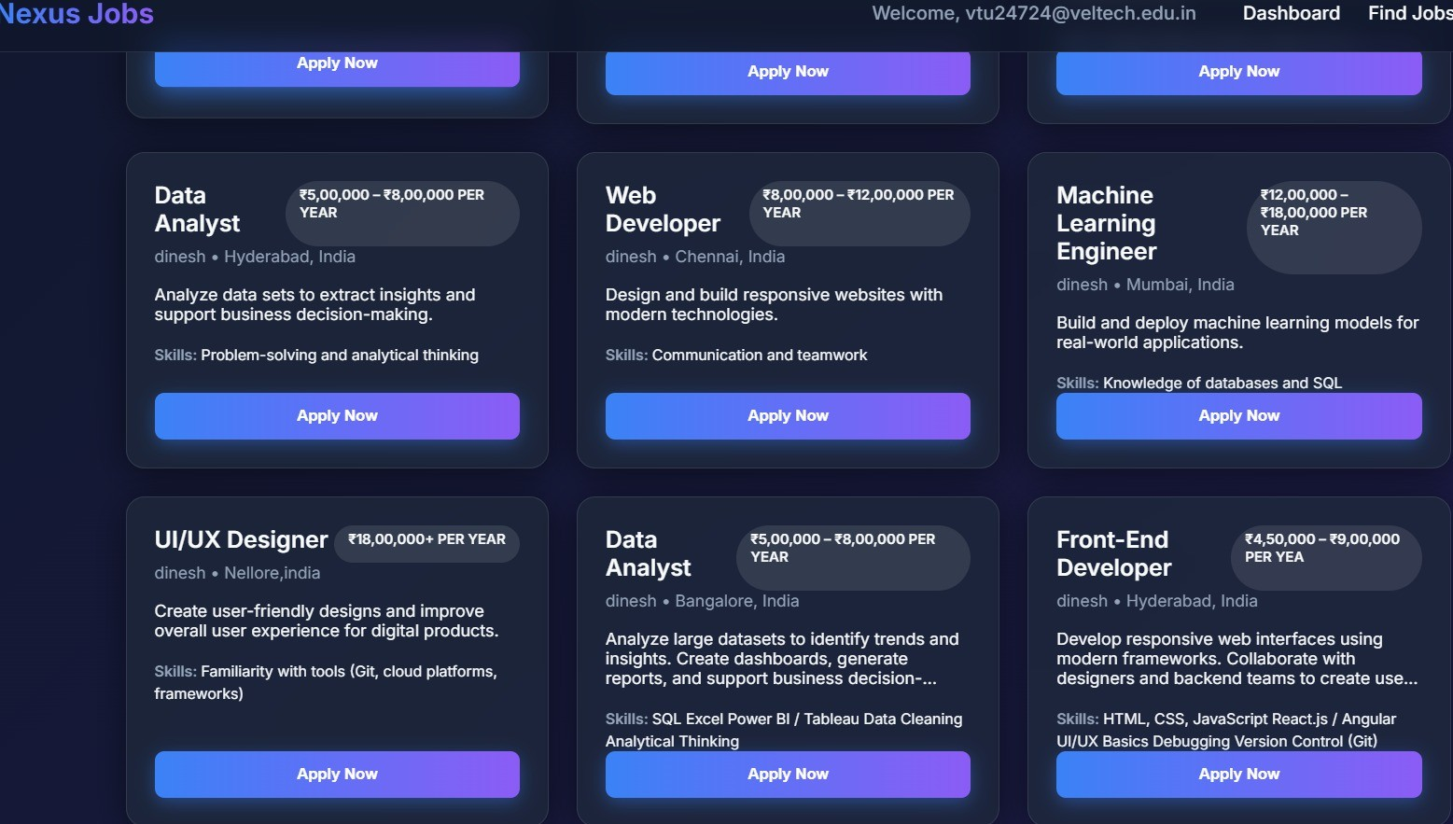

Figure 5.2: job vacancies

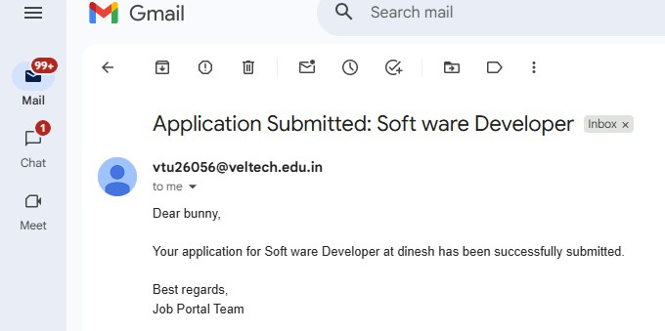

Figure 5.3: Getting notification by Gmail

Application | Advantages
Cvent | Complete event management with advanced features
vFairs | Supports virtual events and enhances user engage-ment
Creatrix | Simple and suitable for campus use
Proposed System | Cost-effective and user-friendly for students
Table 5.1: Application Comparison

Chapter 6 CONCLUSION AND FUTURE

ENHANCEMENTS

Conclusion

The Job Portal Management System provides an efficient solution for managing recruitment activities. It streamlines processes such as job posting, job searching, application submission, and communica-tion through a centralized platform. By reducing manual effort and improving accuracy, the system enhances overall coordination and user experience. It also improves job accessibility by making job informa-tion easily available to users.

Future Enhancements

The system can be further improved by introducing a mobile appli-cation for better accessibility. Features such as real-time notifications,

job recommendations, and application tracking can be added. Inte-gration with third-party services like email and location services can enhance functionality. Strengthening security measures and optimiz-ing system performance will also make the platform more reliable and scalable.

Chapter 7

ADDRESSING COMPLEX ENGINEERING PROBLEM AND SDG

  - Mapping of the Project to Complex Engineering Problem (CEP)

Mapping of the Project to Complex Engineering Activities (CEA)

SDG Mapping

SOURCE CODE
<?php
$conn = new m y s q l i ( ” l o c a l h o s t ” , ” r o o t ” , ” ” , ” j o b p o r t a l ” ) ;

i f ( $conn−> c o n n e c t e r r o r ) {
d i e ( ” C o n n e c t i o n f a i l e d : ” . $conn−> c o n n e c t e r r o r ) ;
}

$message = ” ” ;

/ / Apply Job
i f ( $ SERVER [ ”REQUEST METHOD” ] == ”POST” ) {
$name = $ POST [ ’ name ’ ] ;
$ e m a i l = $ POST [ ’ e m a i l ’ ] ;
$ j ob = $ POST [ ’ j o b ’ ] ;

$ s q l = ” INSERTINTO a p p l i c a t i o n s ( name , email , j o b t i t l e ) VALUES ( ’ $name ’ , ’ $ e m a i l ’ , ’ $ j o b ’ ) ” ;

i f ( $conn−> query ( $ s q l ) === TRUE) {
$message = ” Applied S u c c e s s f u l l y ! ” ;
} e l s e {
$message = ” E r r o r : ” . $conn−> e r r o r ;
}
}
?>

<!DOCTYPE html >
<html >
<head>
< t i t l e >Job P o r t a l </ t i t l e >
</ head>
<body>

<h2> Job P o r t a l </ h2>

<p><b>Company : < / b> Tech S o l u t i o n s Pvt Ltd </p>
<p><b>L o c a t i o n : < / b> Chennai </p>
<p><b>R ole : < / b> S o f t w a r e Developer </p>

<p><b>S a l a r y : < / b> 4 LPA</p>

<?php i f ( $message ) echo ”<p>$message </p>” ; ?>

<form method=”POST”>

< l a b e l >Name: < / l a b e l ><b r >
< i n p u t t y p e =” t e x t ” name=” name ” r e q u i r e d ><b r ><b r >

< l a b e l >Email : < / l a b e l ><b r >
< i n p u t t y p e =” e m a i l ” name=” e m a i l ” r e q u i r e d ><b r ><b r >

< l a b e l >S e l e c t Job : < / l a b e l ><b r >
< s e l e c t name=” j o b ”>
<o p t i o n >S o f t w a r e Developer </ o p t i o n >
<o p t i o n >Web Developer </ o p t i o n >
<o p t i o n >Data Analyst </ o p t i o n >
</ s e l e c t ><b r ><b r >

< b u t t o n t y p e =” s u b m i t ”>Apply Job </ b u t t o n >

</ form>

</ body>
</ html >

Level | Attribute | Characteristics | WKs | Justification
WP1 | Depth of Knowledge | Requires in-depth engineering knowl-edge | WK3, WK4, WK5, WK6 | Requires knowledge of Spring Boot, Spring MVC, Spring Secu-rity, JPA, and database design for building a multi-role job portal  system.
WP2 | Conflicting Requirements | Technical and non-technical conflicts | WK4, WK5, WK6 | Balances role-based access control with usability, ensuring employers and job seekers have separate se-  cure and intuitive workflows.
WP3 | Depth of Analysis | Analytical and de-sign thinking | WK3, WK4, WK5 | It involves entity-relationship mod-eling, REST API design, and inte-gration of file upload and email no-  tification services.
WP4 | Familiarity | Partially new prob-lems | WK4, WK8 | Job-matching and application tracking introduce modern chal-lenges in multi-role web systems beyond traditional CRUD applica-  tions.
WP5 | Applicable Codes | Limited standard so-lutions | WK6 | Requires custom design for resume storage, application status tracking, and dynamic job filtering not fully  covered by standard frameworks.
WP6 | Stakeholder Needs | Multiple stakehold-ers involved | WK5, WK6, WK7 | Handles distinct requirements of job seekers, employers, and ad-mins, ensuring secure and efficient  role-specific interactions.
WP7 | Interdependence | System-level inte-gration | WK3, WK5, WK6 | Integrates frontend, backend, database, file storage, security, and email notification into one unified  system.
Table 7.1: Mapping of Project to Complex Engineering Problem (CEP)

EA No. | Attribute | Characteristics | Justification
EA1 | Range of Resources | Use of diverse tech-nologies | The project uses Spring Boot, Spring MVC, Spring Data JPA, MySQL/H2, Thymeleaf, Spring Se-curity, and JavaMailSender for full-  stack portal development.
EA2 | Level of Interactions | Complex interactions between modules | The system manages layered inter-actions between job listings, appli-cations, user authentication, resume  uploads, and email notifications.
EA3 | Innovation | Application of modern technologies | Integration of role-based dash-boards, dynamic job filtering, file upload handling, and email notifi-  cations demonstrates innovation.
EA4 | Consequences to Society and Environment | Impact on users and so-ciety | Improves employment accessibil-ity, reduces manual hiring over-head, and provides a transparent  and secure digital platform.
EA5 | Familiarity | Beyond standard prac-tices | Combines multi-role authentica-tion, resume management, applica-tion tracking, and dashboard analyt-  ics into a unified portal.
Table 7.2: Mapping of Project to Complex Engineering Activities (CEA)

SDG No. | SDG Title | Relevance to the Project
SDG 8 | Decent Work and Eco-nomic Growth | Facilitates employment by connect-ing job seekers with employers, supporting fair recruitment pro-cesses and improving career oppor-  tunities.
SDG 9 | Industry, Innovation and Infrastructure | Promotes digital transformation in recruitment using REST APIs, dy-namic filtering, and automated no-  tification systems.
SDG 10 | Reduced Inequalities | Provides a standardized, accessible digital platform for all job seekers regardless of geography, reducing barriers to employment opportuni-  ties.
SDG 16 | Peace, Justice and Strong Institutions | Ensures data security and role-based access control using authenti-cation and encryption, maintaining  integrity and fairness.
Table 7.3: SDG Mapping for the Project

References

- LinkedIn Jobs. Available at: https://www.linkedin. com/jobs/
Review: Provides a professional job portal with advanced fea-tures like networking, job recommendations, and application tracking, but can be complex for new users.
- Indeed. Available at: https://www.indeed.com/ Review: Offers a wide range of job listings with simple search and filtering options, but lacks advanced personalization in the basic version.
- Naukri. Available at: https://www.naukri.com/ Review: Popular job portal with resume services and job alerts, but includes paid features for better visibility.
- Glassdoor. Available at: https://www.glassdoor.com/ Review: Provides job listings along with company reviews and salary insights, but some information requires user login.

- Monster. Available at: https://www.monster.com/ Review: Offers global job opportunities and career advice, but the interface can feel outdated.
- Shine. Available at: https://www.shine.com/
Review: Provides job listings and recruiter connections, but in-cludes promotional notifications.
- Freshersworld. Available at: https://www. freshersworld.com/
Review: Focuses on fresh graduates with entry-level job listings, but has limited options for experienced professionals.
- Internshala. Available at: https://www.internshala. com/
Review: Specializes in internships and training programs, but has fewer full-time job opportunities.
- Upwork. Available at: https://www.upwork.com/ Review: Freelance job platform with global reach, but involves competition and service fees.

